ACTIVITY NAME
MOBILE TEXT NEW REGISTRATION PROCESS
TEXT CODE: XXXX
We’re starting a new way to track your attendance for UW faculty and staff. This new method involves your cell phone. It’s simple, easy and best of all, no signing in. In order to obtain credit for your participation, please text your attendance following the steps below within 60 minutes prior, during or after the activity. Make sure you have an account on the UW CloudCME page. Here is a TIP sheet on how to create an account to begin the texting process.
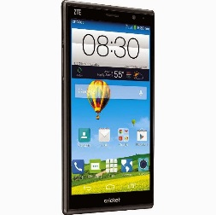 | To Sign-In Using Your Cell Phone  - Send a text message to 833-394-7078  - The message should be the email address associated with your CloudCME Profile (UW faculty and staff should use their UW email address).  Example:  Text: 8333947078  Message: john.doe@uw.edu (use your email address)
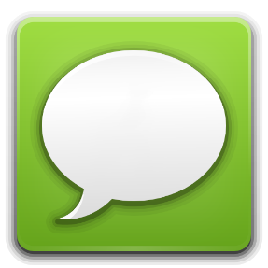 | Text Responses: Step 1  - Once you send your text message, you will receive a reply text that simply says:  “Thank you John Doe, MD, your phone number has been updated to 2065431050.”  - If the response text does not show your name STOP the mobile registration and sign-in the traditional way or create an account at www.uwcme.org.
Text Response: Step 2
- If you received the message “Your phone number has been updated” please continue by entering the activity code provided by the course coordinator.
- If all went well, you should receive a text message that says:

” Thank You John Doe, MD, we have recorded your attendance for Activity CODE and Name Date of Session, 2024. “

- If you do not receive a message like the one above, STOP and sign-in the traditional way and claim credit using the following form.

Your credit is now recorded and available to access using the mobile APP or going to the website and logging into your UW CME Cloud Account Transcript.

