Coordinators Training Manual for Regularly Scheduled Series (RSS)

August 2023

All rights reserved © 2017, 2020, 2021, 2022, 2023

Table of Contents
Table of Contents 2
RSS Dashboard Introduction 3
RSS Icons and Status Definitions 7
Using the RSS Dashboard 9
SMS Texting 11
QR Code Scanning 13
Resources 14

RSS Dashboard Introduction
CloudCME® offers the RSS Dashboard to users who want to easily manage RSS child activities. In the RSS Dashboard, users can view the child status, activity details, presentations and COI status, and target audience. Users can also edit the activity, manage, and email Planners, Faculty, and Owners/Coordinators, upload and download presentations and generate flyers.
First, log into CloudCME®. Click the appropriate sign in method, and then click the Login button.

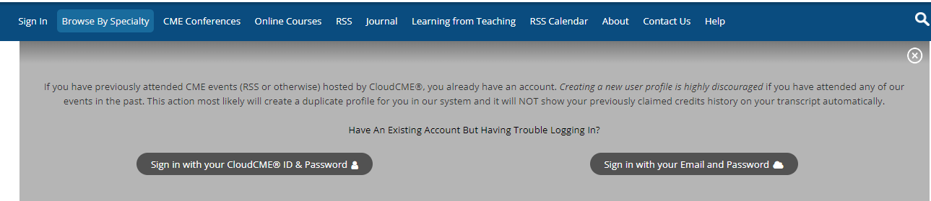

At the bottom of the screen, click the Administration link.

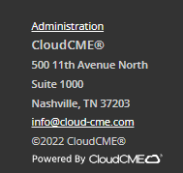

Then, from the main menu, go to Activities > RSS Dashboard.

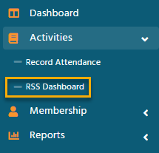

The RSS Dashboard screen will display.
The RSS Dashboard provides a view to easily manage RSS activities. Coordinators will see all activities that they have been assigned as Coordinator/Owner by the Administrator.
There are a variety of ways to search the RSS Dashboard. Search by the activity name, Date Range, Status, Owner, Administrator, Location, Department, Planner, Faculty or Specialty. Click Search to display results in the dashboard.
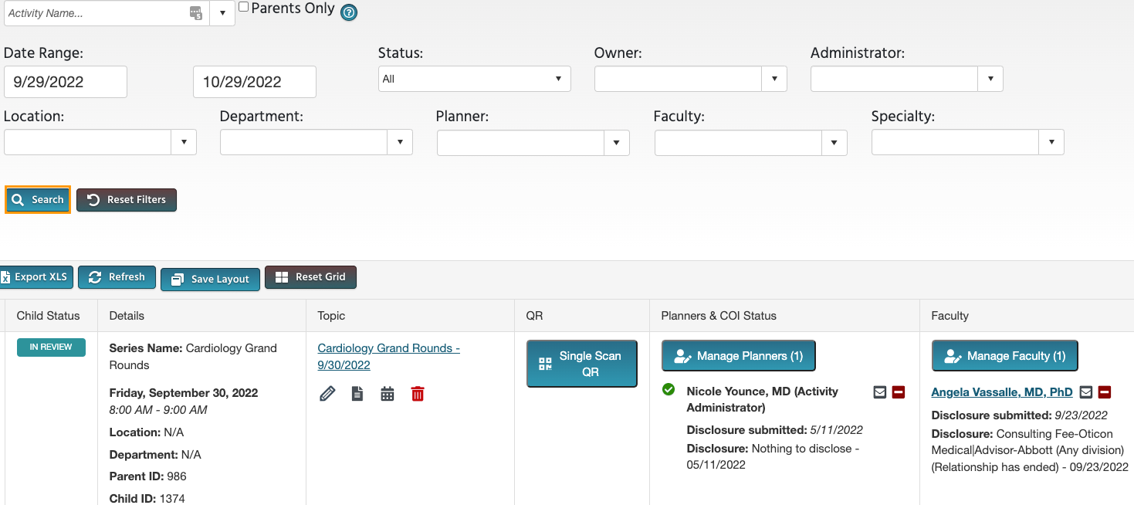

RSS Dashboard Columns
The data table contains several columns to assist the Coordinator in managing the RSS activity planning process.
The following columns are included in the RSS Dashboard:
- Child Status - As the RSS child activity goes through the approval process, this column will continuously update the status to Incomplete, Pending, Approved, Rejected or In Review.
In Review - This status displays if faculty have been added with a completed disclosure and at least one financial relationship has been declared, triggering a COI Mitigation process needed. If one faculty member is rejected, and other faculty have been approved, the Child Status will remain In Review.
A Review Disclosures indicator will display in the Status column if a user has submitted a new Disclosure prior to the activity starting. There may be a new potential COl relationship that needs to be reviewed. Once the COI status has been addressed, the RSS status icon will update to the proper status and the indicator will be cleared.
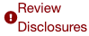
Faculty Added After Approval - This indicator will appear in the Status column to notify Administrators that faculty members have been added to an activity after it has been approved. The status will automatically revert back to IN REVIEW.
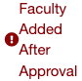
- Details - This column will display the Series Name, the date and time of the child activity, Location, Department, Parent ID and Child ID.
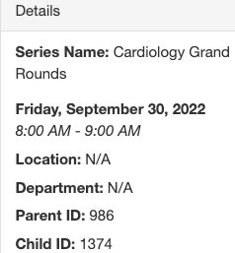
3. Topic - This column displays the name of the RSS child activity as well as the option to edit or create a flyer, view recurrence settings, and delete the activity.
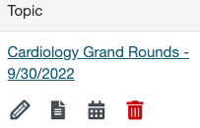

- QR - Single Scan QR is used for recording attendance by users logged in to the CloudCME® mobile app and tapping the Scan Attendance button.
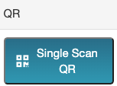
4. Faculty - This column displays Faculty assigned to the RSS child activity. The Disclosure status will display beneath each faculty name along with their Disclosure submission date. If more than 3 faculty members are assigned to the child activity, there will be a "View All" link that when clicked, will expand to show all assigned Faculty, or roll up the listing view.
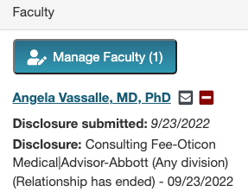
- Clicking the Manage Faculty button will display a pop-up screen that allows RSS Coordinators to email, view, add or remove faculty, request disclosures and file uploads, and export faculty member information.

- To add a faculty member to the activity, type and select the member’s name in the drop-down box. Click the Add Faculty button. The new faculty member will be added to the activity and the member’s information will display in the Manage Faculty table.
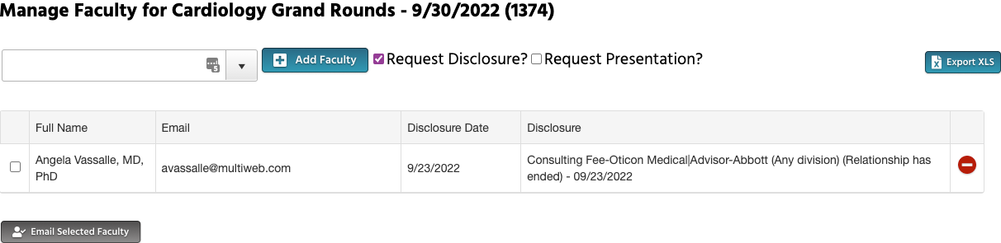
- Click the faculty member’s name to request Disclosures, presentation files and other optional information, edit a user’s profile, and view uploaded files and past courses.
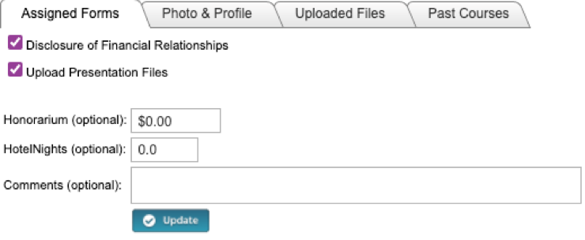
5. Presentation & COI Status - This column displays a faculty members' status, COI status, as well as icons to Upload, Download and Remove a faculty presentation. To upload a presentation, click the Upload icon, complete the Attestation, and select the file that will be uploaded. Once a file has been uploaded, the download and delete icons will display.
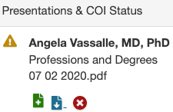
6. Target Audience - This column displays the Specialties and Professions that were selected during the parent activity setup. These can be revised on the RSS Activity Editor when the Pencil icon is selected.
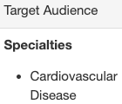
7. Owners/Coordinators - This column displays the child activity Owners' and/or Coordinators' names as well as the option to send emails.
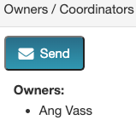

RSS Icons and Status Definitions

The columns in the RSS Dashboard contain several icons:
The following icons (1-4) can be found in the Topic column:
1. Pencil - This icon opens the RSS Activity Editor. Here, a user can edit the child activity information.
2. RSS Flyer - The system will generate an RSS flyer for distribution. Faculty must be assigned to the activity before a flyer can be generated. The flyer template can also be customized for a unique RSS child or parent activity. The template can be applied to all child activities of the parent.
- To associate the revised flyer to the RSS parent for use per each child activity of the parent, click the Upload Flyer button, select the revised flyer from your desktop, and check the Use flyer/template for Parent? checkbox.
NOTE: The RSS flyer will be saved in the Documents tab in Activity Manager for the RSS activity.
3. Calendar - Click this icon to view and edit scheduled RSS child activities.
4. Trash - Click this icon to deactivate/delete an RSS child activity. A pop-up window will display to confirmation deletion.
The following icons (1-8) can be found in the Presentations & COI Status column:
1. Incomplete - This status represents Faculty where there is no disclosure on file, or their disclosure on file has expired. RSS Coordinators/Owners will see Incomplete by default until Faculty are assigned and disclosures have been completed.
2. Pending - This status represents Faculty whose disclosure and presentation are currently undergoing the COI Mitigation process. The system will send an email to the Administrator and Owner, containing all RSS child activities in which the activity status has been changed to Pending.
3. Disclosure Updated - This icon will display if a user has submitted a new disclosure prior to the activity starting. There may be a new COI that needs to be reviewed. Once the COI status has been addressed, this icon will update.
4. Approved - This represents Faculty who have completed a disclosure, no financial relationships have been declared or, if identified, COI mitigation has been satisfactorily completed. The Approved status will also display if an Administrator or Activity Administrator conducts an Approval Override or if in Administration > Preferences > COI Resolution the "Automatically Approve COI When Users Have Nothing to Disclose" checkbox is checked.
5. Rejected - This represents Faculty who have completed a disclosure, at least one financial relationship has been declared, and the conflict is deemed immitigable. The child activity status is then updated to Rejected. The Coordinator will remove this faculty member, select a new faculty member, and begin the process again.
6. Upload - Upload a presentation file for the faculty member. Once a presentation has been uploaded, the download and delete icons will display.
7. Download - Download a faculty member's presentation file.
8. Delete - Delete a faculty member's presentation file.

The following icons (1,2) can be found in the Faculty and Planner columns:
1.Email: Draft and send an email to the selected Faculty Member/Planner.
2.Remove: Remove a Faculty Member/Planner from the RSS child activity.

The following button can be found in the Owners/Coordinators column:
1. Draft and send an email to Owners/Coordinators.

Using the RSS Dashboard

Click the calendar icon () in the Topic column to display a pop-up window that will show a calendar with the reoccurrence dates of the child activities. To change the date of a child activity, users can drag and drop the child activity to a new day.

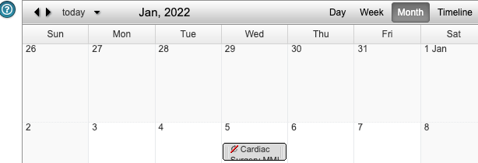

To edit a child activity, double-click on the activity in the calendar. A pop-up window will display. The radio button will default to Edit only this occurrence.
This option will only edit the child activity that was selected. To edit the entire series of child activities, select the Edit the series radio button. Click OK.
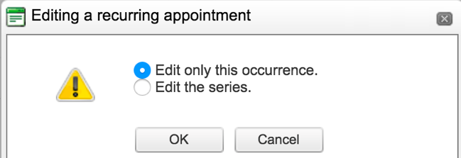
To edit the title of the child activity, type the new title into the textbox that will display. To revise the date or time the activity will occur, click the Options button.
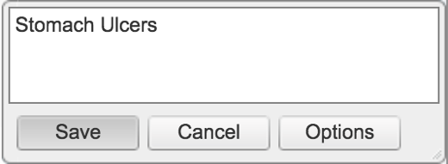
A new window will display. Here, users can create a child activity by filling in the text box, selecting the date and time the child activity will occur, and whether the activity have a recurrence.

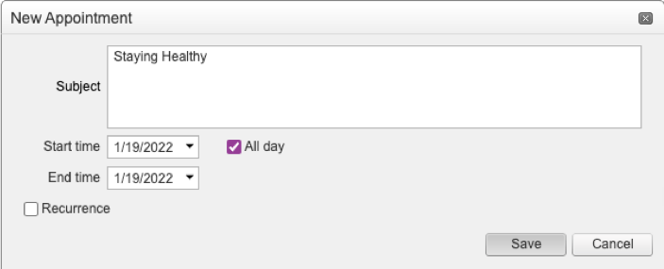

Click the Pencil icon from the RSS Dashboard activity with the updated title. This icon can be found in the Topic column. The RSS Activity Editor screen will display. Here, users can edit and/or add additional information and upload supporting documentation for the child activity.

NOTE: The child activity title will display on users’ transcripts.

When all information has been entered, click the Save & Close button.

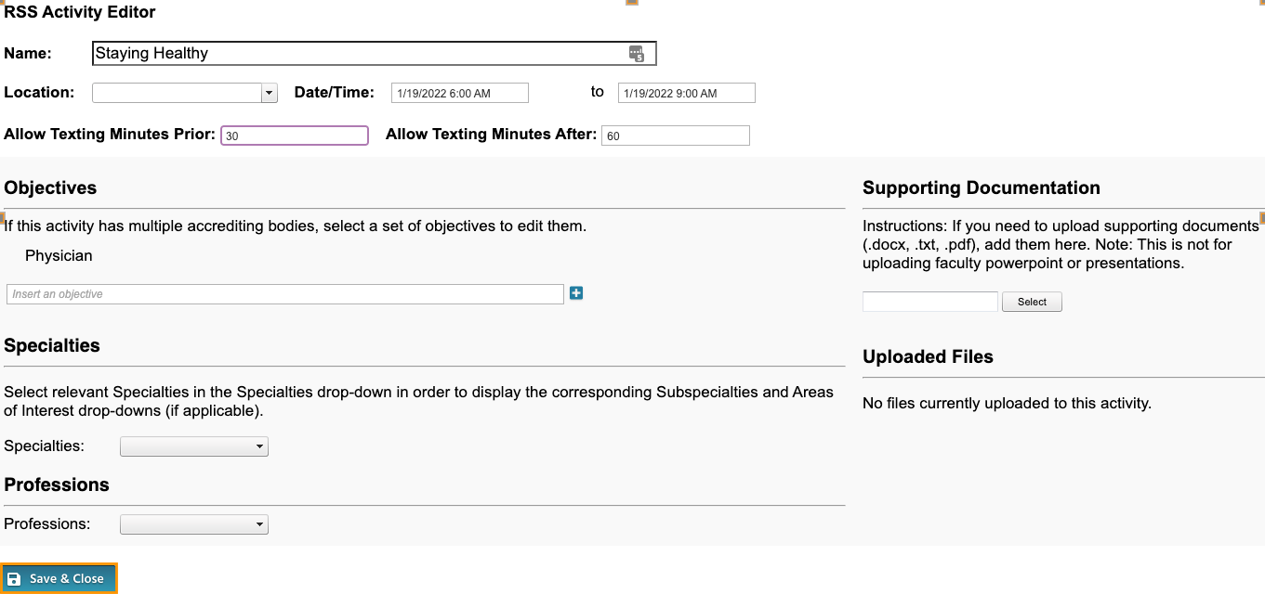
To customize the RSS flyer, click the RSS Flyer icon () and then click the Download Microsoft Word Version link. The flyer will open as a Word document. Make the desired changes and click Save.
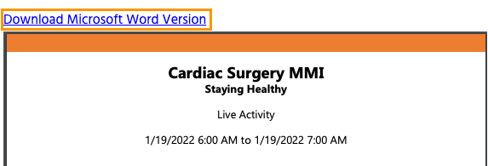
NOTE: A list of merge fields that can be used in the RSS Flyer can be found here: Document Merge Fields.
To associate the revised flyer to the RSS parent for use per each child activity of the parent, click the Upload Flyer button, select the revised flyer from your desktop, and check the Use flyer/templates for Parent? checkbox. Then, click the Save button.
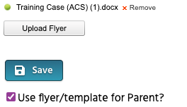

SMS Texting

These instructions are intended only for users that have an active account in CloudCME®. Attendance can only be recorded 60 minutes prior to the activity, during the activity, or 120 minutes after the activity.
Step 1: First, users must pair their mobile phone to their account in CloudCME®. Text the email address associated with this account to, (866) XXX-XXXX. A message will be sent that looks like the one below, confirming that the phone number has been updated.

NOTE: This is a one-time operation.

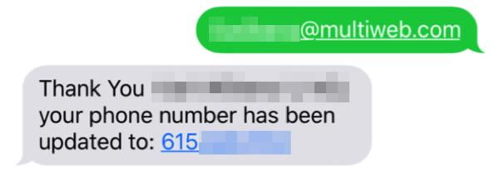

Step 2: To record attendance to an activity, text the activity ID or code that has been provided for the activity. A message will be sent that verifies that activity attendance has been recorded.
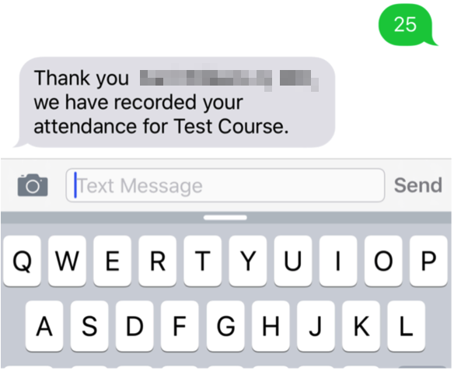

NOTE: Attendance can only be recorded once to an activity. If a user tries to record attendance an additional time, they will receive the following message:

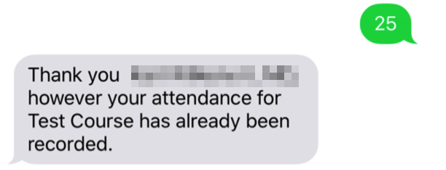

If a user attempts to use an activity code that does not exist, they will receive the following message:

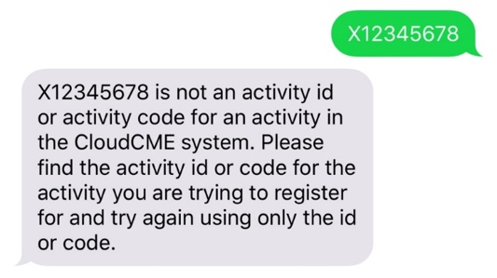

QR Code Scanning

These instructions are intended only for users that have an active account in CloudCME® and are using the CloudCME® mobile app and tapping the Scan Attendance button in the app. Attendance can only be recorded 60 minutes prior to the activity, during the activity, or 120 minutes after the activity.

Step 1: First, users must have access to the CloudCME® mobile app. Download the app and login once, then all My CME content, CE tasks, activity listings, and Scan Attendance will be available from the mobile device.

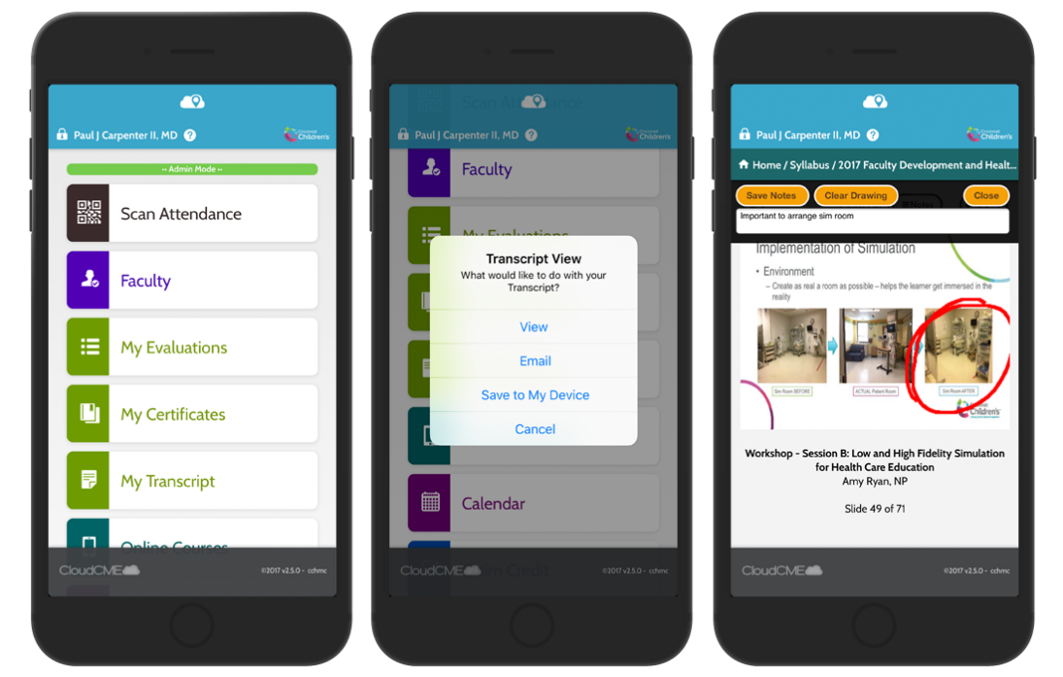

Download Links

Download the app for free from the app store and login using their organizational code (which is the prefix to your CloudCME® portal URL, XXX.cloud-cme.com). Then, enter your CloudCME® username and password. Both institutional Single Sign-On and non-Single Sign-On CloudCME® account types are supported.

Apple iOS - https://itunes.apple.com/us/app/cloudcme/id624053130?mt=8
Google Android - https://play.google.com/store/apps/details?id=com.cloudcme.checkin&hl=en_US&gl=US
Step 1: Download App if you have not already
Step 2: Open the app, use organization code “XXXX”
Step 3: Click the Login or Create Account button.
Step 4: Login using your email address and password.

Step 2: Once logged in, the user will scan the QR code that can be generated from the RSS Dashboard to record their attendance. These QR codes can either be printed or included as part of a presentation slide, then scanned using the Scan Attendance feature in the mobile app.

Resources

Please find below a few helpful videos that review the RSS Dashboard and the Record Attendance screen:

RSS Dashboard Training Video
Record Attendance Training Video

NOTE: You must be logged in to the CloudCME Administration site to view these videos.

Note: Log in to the CloudCME® Administration area before clicking the Help article links.
You must text an SMS text message not an iMessage, if using iOS.

