<<EVENTDATES>>

Description:

Objectives: At the conclusion of this activity, the participant should be able to:
1.
2.
3.

Location:

Registration Details:

Disclosure of Financial Relationships:

Accreditation Statement:
Accreditation with Commendation: The University of Washington School of Medicine is  accredited by the Accreditation Council for Continuing Medical Education to provide  continuing medical education for physicians. | 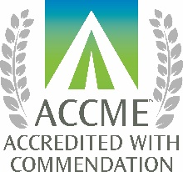
Credit Designation:
The University of Washington School of Medicine designates this “activity format” activity for a maximum of {CMEHours} AMA PRA Category 1 Credits™. Physicians should claim only the credit commensurate with the extent of their participation in the activity.

Other Healthcare Professionals
Other healthcare professionals who participate in this CE activity may submit their statement of participation to their appropriate accrediting organizations or state boards for consideration of credit. The participant is responsible for determining whether this activity meets the requirements for acceptable continuing education.

